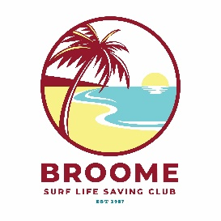
BROOME SURF LIFE SAVING CLUB

Weather Policy

Policy Number: BSLSC-011

Purpose of the Policy
This policy has been put in place to ensure the safety of all visitors to the Surf club during a weather event.

Policy principles
Rain and Lightning
The BSLSC will continue to operate during rain and lightning events. If severe lightening/ significant rain is within sight of the surf club, bar trading may halt until safe to re-open, as determined by the Club Manager, or Approved Manager on site.

Severe weather warnings (SWW)
The BOM offers advice on severe weather warnings. When a SWW is issued, the BSLSC will close to trade. Office staff will work from home until the SWW clears or the following day of trade.

Cyclones
There are three warning levels which move up and down to reflect the risk to your life or property before, during and after a cyclone. These are the same warning levels as bushfires, flood and storm:

- Advice: An incident is active. Be aware and keep up to date.
  - BSLSC is open for trade.
- Watch and Act: There is a possible threat. Take action now to stay safe.
  - BSLSC is closed to trade. Office staff and volunteers to work from home until the status moves back to advice, the cyclone warning is no longer in place, or the following day of trade.
- Emergency Warning: There is a threat to lives and homes. You may be in danger and need to take immediate action.
  - BSLSC is closed to trade. Staff are paid as per award/contracts and are not required to work. A determination will be made by the current board as to when the club will re-open.

Roles and Responsibilities
The Club Manager is responsible for communicating weather related decisions from the board to staff or vice versa. The Board of Directors will ensure compliance with this policy.

Related Documents
Nil

This document has the following amendment history:
Revision Date | Version | Amendment/s
31/03/2026 | 1.0 | Original Weather Policy approved at Board Meeting

